Reverse engineer an existing database into a database model

*Visio Plan 2 Visio Professional 2024 Visio Professional 2021 Visio Professional 2019*

With the Reverse Engineer Wizard, you can create a database model from an existing database or an Excel workbook. Database models graphically show the structure of a database so you can see how database elements, such as tables and views, relate to each other without showing the actual data. This can streamline creating a new database or understanding the structure of an existing one.

**Important:**Reverse engineering is supported for SQL Server 2016 and earlier versions. It is **not** supported for SQL Server 2019 or newer versions.

The Database Model Diagram template lets you create a database model from an existing database. This template is available in the Visio app for those with [Visio Plan 2](https://www.microsoft.com/microsoft-365/visio/visio-plan-2?ocid=cmm6ctxrfp1) or a Visio license. If you're not sure what version of Visio you're using, click **File** > **Account** > **About Visio**.

Review what the Reverse Engineer Wizard extracts

The schema definition information that the wizard can extract depends on a combination of things, such as the capabilities of the database management system (DBMS) and ODBC driver. The wizard shows all the elements it can extract and lets you choose which ones you want. For example, you may be interested in only 5 out of 10 tables, and 2 out of 4 views.

While you are running the wizard you can choose to have it automatically create the drawing in addition to listing the reverse engineered items in the Tables and Views window. If you decide not to have the drawing created automatically, you can drag the items from the Tables and Views window onto your drawing page to manually assemble the database model.

To the extent that they are available from the target DBMS, you can extract the following:

* Tables
* Views
* Primary keys
* Foreign keys
* Indexes
* Triggers (including code)
* Check clauses (including code)
* Stored procedures (including code)

Prepare to start the wizard

If you are reverse engineering an Excel workbook, before you start the wizard you need to open the workbook and name the group (or range) of cells that contain the column headings. If you want to use more than one worksheet, just name the group of column cells in each worksheet. These ranges are treated like tables in the wizard. For more information about how to name a range of cells, see the Excel help.

For best results, set your default driver to the target database that you want to reverse engineer before you run the Reverse Engineer Wizard. This ensures that the wizard maps the native data types correctly and that all the code extracted by the wizard displays correctly in the Code window.

1. Click the **File** tab, click **New**, click **Templates**, click **Software and Database**, and then double-click **Database Model Diagram**.
2. On the **Database** tab, in the **Manage** group, click **Database Drivers**.
3. On the **Drivers** tab select the Visio-supplied driver for your DBMS. For example, if you are designing an Access database you would choose Microsoft Access.

If you are reverse engineering an Excel worksheet, choose the ODBC Generic Driver.

1. Click **Setup**.
2. On the **ODBC drivers** tab, select the check box for the vender-supplied driver for your DBMA. For example, if you are designing an Access database you would select the **Microsoft Access Driver (*.mdb, *.accdb)** check box.
3. Click **OK** in each dialog box.

A vendor-supplied 32-bit ODBC driver must be from an ODBC Data Access Pack greater than version 2.0 and ODBC Level 1-compliant or greater. A vendor-supplied OLE DB provider must be compliant with the OLE DB version 1.0 or later specification.

Reverse engineer an existing database

1. In your database model diagram, on the **Database** tab, click **Reverse Engineer**.
2. On the first screen of the Reverse Engineer Wizard, do the following:
   1. Select the Microsoft Visio database driver for your database management system (DBMS). If you have not already associated the Visio database driver with a particular ODBC data source, click **Setup** to do so now.

If you are reverse engineering an Excel worksheet, choose the ODBC Generic Driver.

* 1. Select the data source of the database you are updating. If you have not already created a data source for the existing database, click **New** to do so now.

When you create a new source, its name is added to the **Data Sources** list.

* 1. When you are satisfied with your settings, click **Next**.
  2. Follow the instructions in any driver-specific dialog boxes. For example, in the **Connect Data Source** dialog box, type a user name and password, and then click **OK**. If your data source isn't password protected, click **OK**.

1. Select the check boxes for the type of information that you want to extract, and then click **Next**.

Some items may be grayed out because not all systems support all the kinds of elements the wizard can extract.

1. Select the check boxes for the tables (and views, if any) that you want to extract, or click **Select All** to extract them all, and then click **Next**.

If you are reverse engineering an Excel worksheet and don't see anything in this list, then it is likely that you need to name the range of cells that contain the column headings in your spreadsheet.

1. If you selected the **Stored Procedures** check box in step 3, select the procedures that you want to extract, or click **Select All** to extract them all, and then click **Next**.
2. Select whether you want the reverse engineered items added automatically to the current page.

You can choose to have the wizard automatically create the drawing in addition to listing the reverse engineered items in the Tables and Views window. If you decide not to have the drawing created automatically, you can drag the items from the Tables and Views window onto your drawing page to manually assemble the database model.

1. Review your selections to verify that you are extracting the information you want, and then click **Finish**.

If you use the ODBC Generic Driver, you may receive an error that indicates that the reverse engineered information may be incomplete. In most cases this isn't a problem — just click **OK** and continue with the wizard.

The wizard extracts the selected information and displays notes about the extraction process in the Output window.

**Reverse Engineering an Existing Database**

Reverse engineering is the process of constructing a data model from an existing database. When you reverse engineer a database in Astera Data Stack, it creates a logical structure that incorporates the tables in the database, and the relationships between them. In essence, It synchronizes the data model with the database and its entities.

**Video**

**Overview**

There are two ways to reverse engineer a database in Astera Data Stack. One is from the toolbar on the data model designer and the other one is from the main menu.

Let’s explore each, one by one.

**Reverse Engineer: Using the Tool Bar Icon**

On the toolbar of the data model designer, there is an icon for reverse engineering.

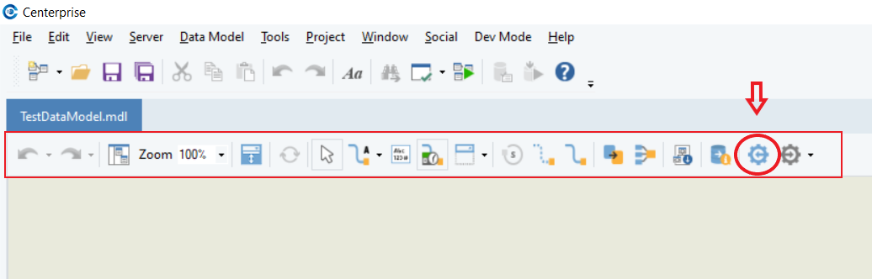

**Reverse Engineer: Using the Main Menu**

On the main menu bar of Astera Data Stack, there is an option for *Data Model > Reverse Engineer*.

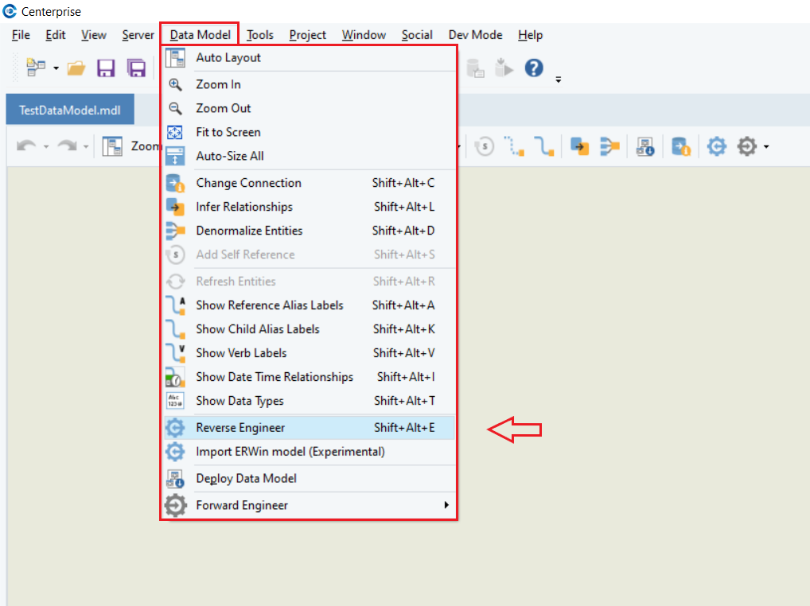

Once you select either of these two options, a *Reverse Engineering* wizard will open on the screen.

In case you haven’t established a database connection earlier, specify a connection from within the *Reverse Engineering* wizard.

Click on the ellipses in front of the *Database Connection* option. A *Database Connection* screen will open.

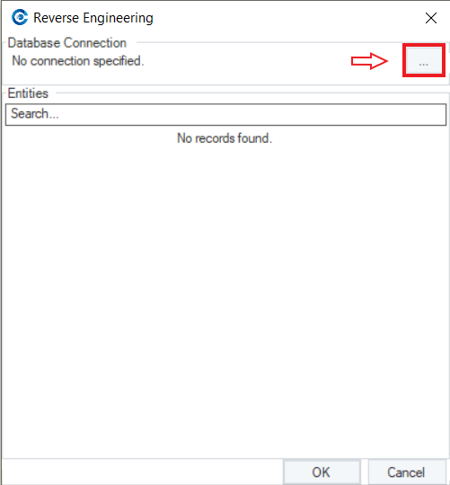

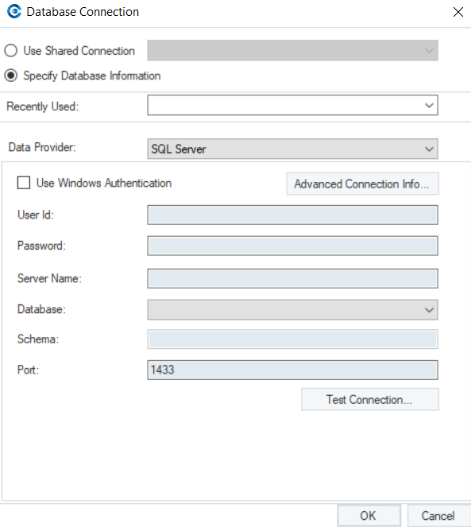

On this screen, select the data provider for the database and fill in the required credentials. Once done, click *OK*.

There is a list of data providers that Astera Data Stack supports.

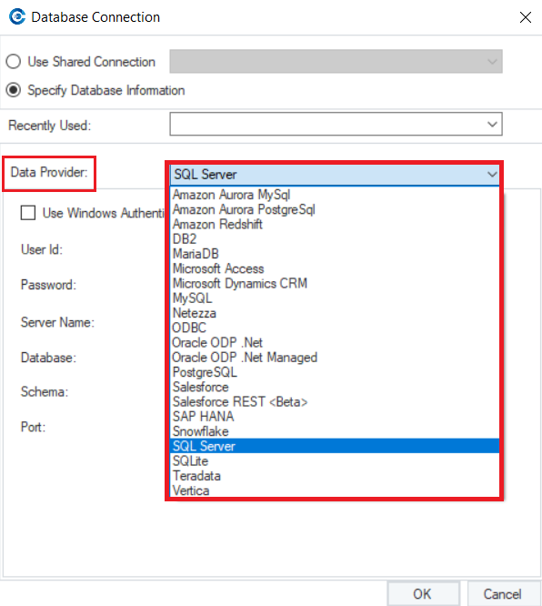

**Note**: In this case, we will select SQL Server as our database provider.

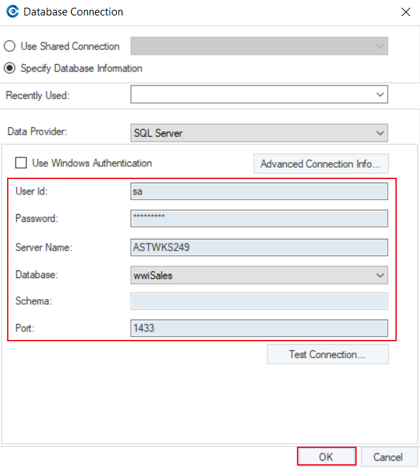

Now, all the tables in the database have been listed as *Entities* on the Reverse Engineering wizard.

The following information is available for each entity:

* Exist? - Identifies if the entity already exists in the model
* Type - Specifies the type of the entity in the database (Example: Table)
* Schema - Represents the schema that the entity belongs to in the database
* Name - Name of the entity in the database

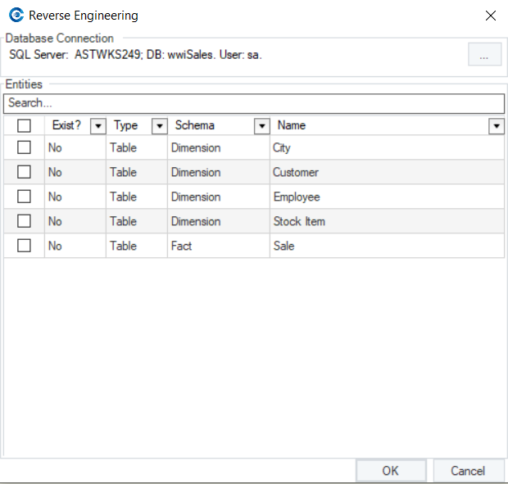

Select the entities that you want to reverse engineer in the data model.

**Note**: In this case, we are selecting all the listed entities.

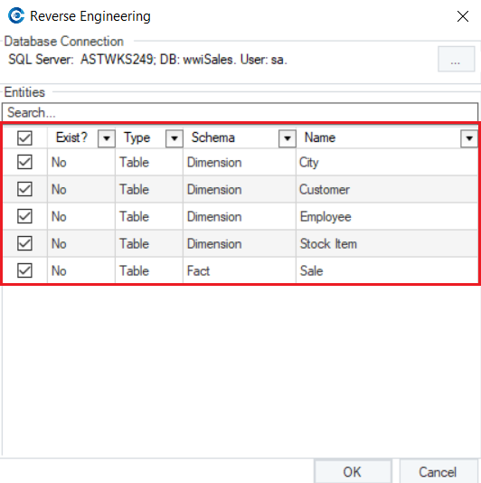

On the *Reverse Engineering* wizard, there is a *Search* option that can be used when there are numerous listed entities and specific entities are to be reverse engineered from the database.

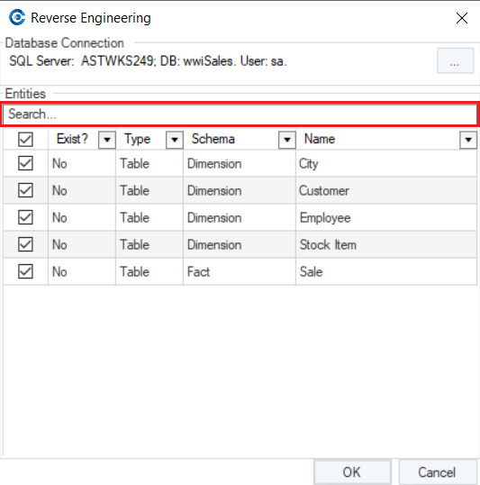

There is also an option to filter out listed entities for each information type provided. Upon selecting the filter, it would open a new wizard where you can specify filter options.

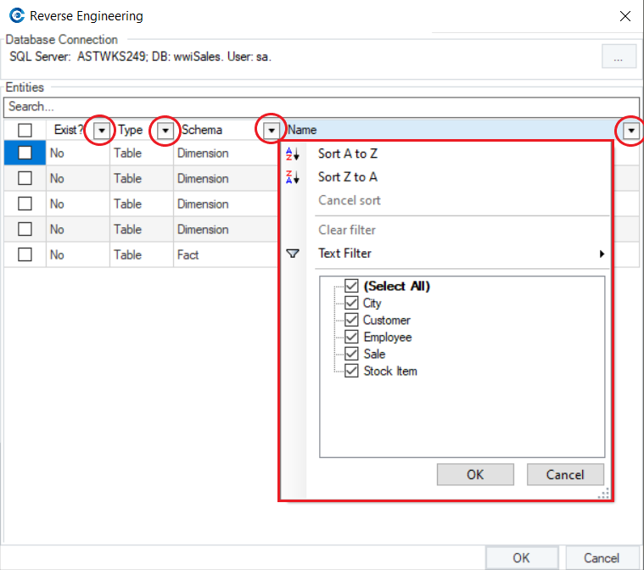

Once you’ve selected the entities for reverse engineering, click *OK*.

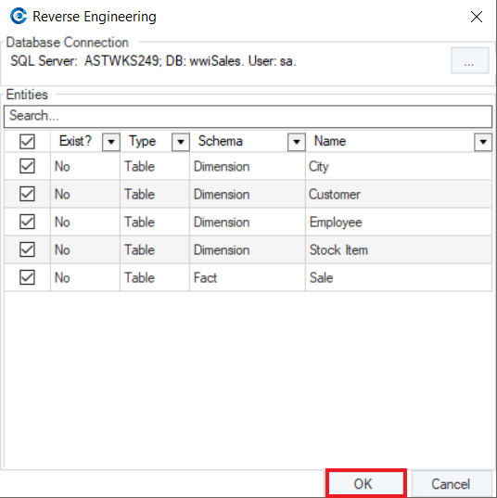

When the process is complete, the selected entities from the database will appear on the data model designer.

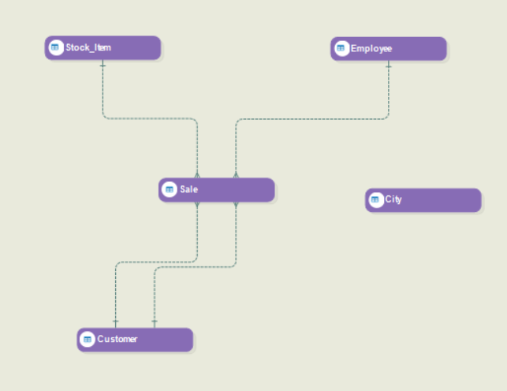

This concludes our discussion on reverse engineering an existing database in Astera Data Stack.